**Operating System**

**(CT-353)**

Lab no 14

**1) Implement the above code and paste the screen shot of the output.**

**CODE:**

**A) SEQUENTIAL**

#include <stdio.h>

int main() {

int f[50] = {0}; // Block status: 0 = free, 1 = allocated

int i, st, len, j, c;

do {

printf("\nEnter the starting block and length of the file: ");

scanf("%d %d", &st, &len);

int allocated = 1;

for (j = st; j < st + len; j++) {

if (f[j] == 1) {

printf("Block %d is already allocated.\n", j);

allocated = 0;

break;

}

}

if (allocated) {

for (j = st; j < st + len; j++) {

f[j] = 1;

printf("%d -> Allocated\n", j);

}

printf("The file has been allocated.\n");

}

printf("Do you want to enter more files? (1 for Yes / 0 for No): ");

scanf("%d", &c);

} while (c == 1);

return 0;

}

**OUTPUT:**

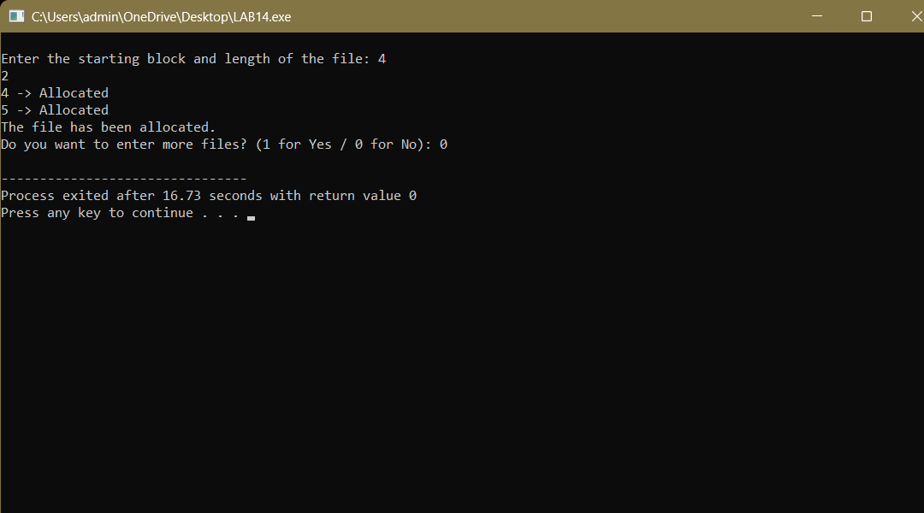

**B) Indexed**

#include <stdio.h>

int main() {

int f[50] = {0};

int inde[50];

int i, n, p, c;

do {

printf("Enter index block: ");

scanf("%d", &p);

if (f[p] == 1) {

printf("Block already allocated.\n");

continue;

}

f[p] = 1;

printf("Enter number of blocks needed: ");

scanf("%d", &n);

printf("Enter the block numbers:\n");

int valid = 1;

for (i = 0; i < n; i++) {

scanf("%d", &inde[i]);

if (f[inde[i]] == 1) {

printf("Block %d already allocated.\n", inde[i]);

valid = 0;

}

}

if (!valid) continue;

for (i = 0; i < n; i++) {

f[inde[i]] = 1;

}

printf("File indexed.\n");

for (i = 0; i < n; i++) {

printf("%d -> %d: Allocated\n", p, inde[i]);

}

printf("Do you want to enter more files? (1 for Yes / 0 for No): ");

scanf("%d", &c);

} while (c == 1);

return 0;

}

**Output**

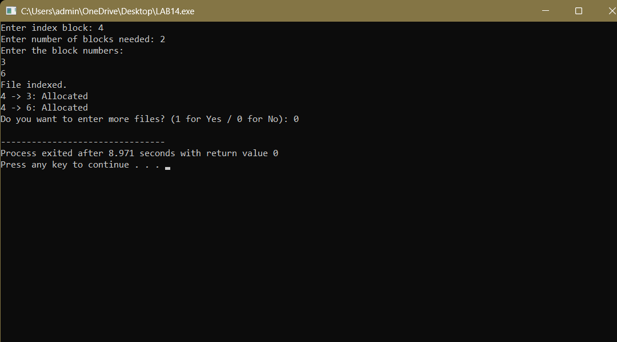

**C) Linked**

#include <stdio.h>

int main() {

int f[50] = {0};

int i, j, p, a, st, len, c;

printf("Enter how many blocks are already allocated: ");

scanf("%d", &p);

printf("Enter the block numbers that are already allocated:\n");

for (i = 0; i < p; i++) {

scanf("%d", &a);

f[a] = 1;

}

do {

printf("Enter the starting index block and length of the file: ");

scanf("%d %d", &st, &len);

int k = len;

for (j = st; j < st + k; j++) {

if (f[j] == 0) {

f[j] = 1;

printf("%d -> Allocated\n", j);

} else {

printf("%d -> Block already allocated. Searching next...\n", j);

k++; // Extend search to compensate

}

}

printf("Do you want to enter another file? (1 for Yes / 0 for No): ");

scanf("%d", &c);

} while (c == 1);

return 0;

}

**Output:**

